Jennifer Kramer

Software Developer | Graphic Designer

JenKrame@gmail.com | 561.455.6447 | Boynton Beach, Florida

[Portfolio](https://my-portfolio-six-orpin.vercel.app/) | [GitHub](https://github.com/jenkrame21) | [LinkedIn](https://www.linkedin.com/in/creationsbyjenniferkramer/)

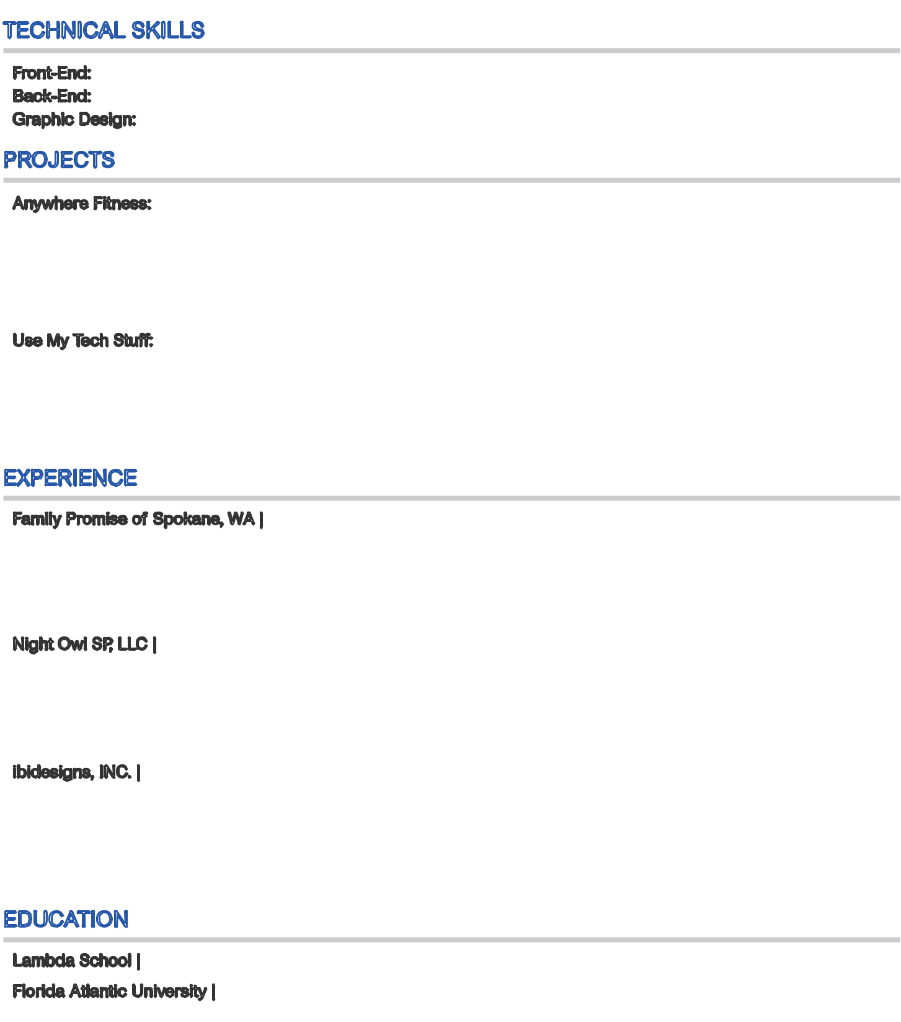

TECHNICAL SKILLS

Front-End: JavaScript | Python | React | Redux | HTML | CSS | Sass | Responsive Web Design | Accessibility

Back-End: Node.js | RESTful API | PostgreSQL | Postman | Express | Helmet | Cors | Knex | Jest

Graphic Design: Photoshop | Illustrator | InDesign | Acrobat | Product Photography | Social Media Content Creation

PROJECTS

[Anywhere Fitness:](https://anywhere-fitness-tt39-tt39.vercel.app/) React | Redux | Custom Hooks | HTML | CSS [GitHub Repo](https://github.com/Build-Week-Anywhere-Fitness-TT39/front-end/)

An app designed for fitness instructors and clients to meet virtually and physically anywhere

* Created Login and Sign-up Page routes with proper validation in place within a span of two days
* Implemented a redux store complete with actions and reducers with one other developer within one week
* Built responsive design utilizing the styled components library

[Use My Tech Stuff:](https://friendly-hamilton-b1c31c.netlify.app/) Node.js | Express | Helmet | Cors | RESTful API | Jest [GitHub Repo](https://github.com/ttwebft20-Use-My-Tech-Stuff/node-back-end)

An app designed for tech owners to rent out their tech items to anyone locally present

* Soley designed the complete back-end architecture using RESTful endpoints all within two days
* Operated and communicated with the front-end team regarding data structures within a span of one week
* Built custom middleware regarding proper authorizations between owners and renters

EXPERIENCE

|  |  |  |
| --- | --- | --- |
| Family Promise of Spokane, WA | Remote | May - June 2021 |  |
|  |  |

Backend Developer & UI Designer | Contract

* Collaborated with a back-end team to develop multiple RESTful APIs within a span of one month
* Built two graphic visuals of the user hierarchy and the scope of their permissions
* Created Figma UI mockups of possible future developments, ie. showing metrics data and map pinpoint functionality

Night Owl SP, LLC | Boca Raton, FL August 2017 - September 2019 Graphic Designer

* Designed and updated Quick Setup Guides and manuals of security products using Illustrator and InDesign
* Photographed and edited security products for print and web purposes within a span of one week
* Developed line art to demonstrate setup of products utilizing Illustrator within one day

ibidesigns, INC. | Boca Raton, FL January 2016 - July 2017 Photo Editor

* Combined multiple photo stills of luxurious, residential real estate properties worth 1 million or more USD to be utilized for marketing purposes in both digital and print format within a span of one day
* Corrected any imperfections that were in the photographs such as telephone poles, brown patches of grass, reflections of camera equipment and photographer, and unnecessary items using Photoshop within one day

EDUCATION

|  |  |  |
| --- | --- | --- |
| Lambda School | Full Stack Web Development & Computer Science | Remote | September 2020 | - May 2021 |
| Florida Atlantic University | Bachelor of Arts: Visual Arts Major | Boca Raton, FL | August 2008 | - May 2013 |